Introduction
In this analytical report, the following chemical substances, 1,2-dichlorobenzene, hexane, 1-chloro-2,2,4-trimethylpentane, 2,6-dinitrotoluene, and pentachlorophenol will be ranked according to a specific set of criteria to determine the safest course of action for manufacturing your company’s electronic component products. In order to ascertain the most viable substitute for your company’s now-banned chemical cleaning agent, each chemical substance will be judged in accordance with their immediate and potential risk to both the environment and locals in nearby residential areas. The particular properties this report will use to narrow down the options include: toxic potency in a marine environment, potential for bioaccumulation, daily uptake by humans, as well as overall persistence. The final ranking order will assist your company in determining the chemical substance that carries the least significant environmental effects.

Methods
This report uses toxicity values from the US EPA Ecotox database to determine the potential lethal effects on fish in a lake adjacent to your company’s main factory. Fugacity models level I and II will also serve as valuable tools for gauging human exposure to each chemical substance, and will aid in measuring residence time in different environmental media, respectively. Lastly, a bioaccumulation model will assist in pinpointing the chemicals that could cause harmful effects in a marine environment through trophic interactions. Final concentrations generated by fugacity model level I were used in the bioaccumulation model.
Data inputs used in the fugacity models were collected from the Ecotox database. Chemical input, inflow concentration in water and inflow concentration in air were assumed to be 1.00E+02 moles/day, 1.00E-03 mol/m^3, and 1.00E-06, respectively. The volume of the lake water was estimated to be 1.67E+12 m^3. Temperature was considered constant in all of the calculations at 25 deg C.

Table 1.1-Data Inputs for the Fugacity Models
This table shows the main parameters derived from the US Environmental Protection Agency Ecotox database used in fugacity models I and II.
Chemical Name | Water Solubility (g/m^3) | Vapor Pressure  (Pa) | Log(Kow) | Henry’s Law Constant (Pa*m^3/mol)
1,2-dichlorobenzene | 154 | 195.98 | 3.43 | 187.08
Hexane | 9.5 | 20131.68 | 3.9 | 182626.1
1-chloro-2,2,4-trimethylpentane | 15.13 | 693.28 | 4.34 | 6.8E+03
2,6-dinitrotoluene | 2.27E+04 | 2.27E+04 | -0.02 | 2.69E-11
Pentachlorophenol | 14 | 1.47E-02 | 4.74 | 0.28

Table 1.2-Reaction Half-Lives (days) for each Chemical
This table shows the half-life input values for Fugacity Model Level II. Values were taken from Environment Canada and Chemspider reports.
Chemical Name | Soil | Sediment | Biota | Suspended Sediment | Water | Air
1,2-dichlorobenzene | 9 | 338 | 2 | 630 | 13 | 38
Hexane | 182 | 78 | 1 | 365 | 182 | 2
1-chloro-2,2-4-trimethylpentane | 75 | 338 | 1 | 465 | 38 | 2
2,6-dinitrotoluene | 20 | 92 | 0.1 | 180 | 0.5 | 75
Pentachlorophenol | 45 | 180 | 2 | 380 | 3 | 10

A grading scheme was developed to properly evaluate each chemical in terms of its environmental impact and hazardous effects to human health. Toxicity (LC-50), persistence (residence time and half-life), and bioaccumulation potential comprise the foundation for the criteria used in this particular risk assessment. Greater emphasis was placed on chemical substances that were more toxic and caused greater fish mortality, regardless of their persistence and bioaccumulation capacities.

Table 1.3-Environmental Impact Ranking Criteria
Risk Factor | Prerequisites
Class 1-Immediately harmful to humans, marine species and the surrounding environment | LC-50 is very low (<5000 μg/L) and the chemical is highly persistent
Class 2-Considerable risk to humans and the environment | High Toxicity and can be easily transported through different routes of exposure. Somewhat persistent
Class 3-Moderate risk to humans and the environment | May not necessarily be toxic, but is highly persistent in the environment
Class 4-Potential risk to humans and the environment | Chemical substance has enormous bioaccumulation potential but not immediately harmful and possesses a low toxicity
Class 5-Low risk | Minimal immediate or potential risk to humans or the surrounding environment

Results
I. Toxicity
To estimate relative toxicity, the LC-50 for fathead minnows and rainbow trouts was calculated for each of the 5 chemicals. An average of the 2 values was used to produce a rough estimate of the lethal concentrations in a marine environment. The data pertaining to toxicity showed that pentachlorophenol (PCP) had the greatest capacity for causing 50% fish mortality under low concentrations, and since PCP is highly soluble in water, the likelihood of fish kills is extremely high. Correspondingly, hexane’s propensity for dissolving in water was shown to be greater than its LC-50, and thus is capable of causing fish kills as well. In stark contrast, 1,2-dichlorobenzene required the highest concentration for 50% fish mortality.

Figure 2.1
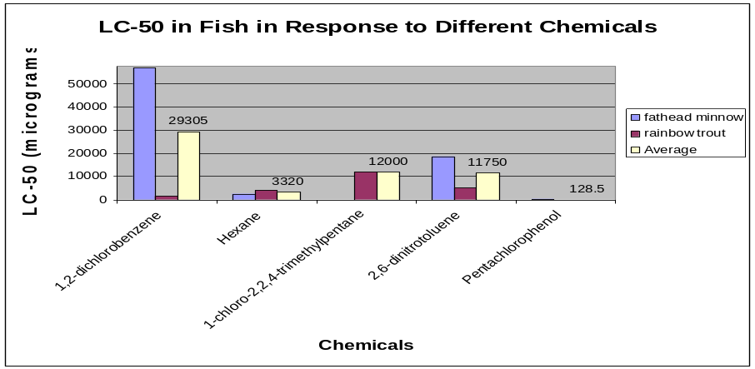
The figure shown below compares each chemical based on their lethal concentrations in 2 different fish populations. By observation, pentachlorophenol is shown to cause 50% mortality in fish with the least amount of concentration. On the other hand, 1,2-dichlorobenzene carried the highest LC-50 value out of the 5 chemicals. All LC-50 values were observed within 4 days.

Data Source: US Environmental Protection Agency Ecotox Database.

II. Equilibrium Chemical Distribution and Human Exposure

A level I fugacity model was used to take into account both exposure pathways and migration patterns of chemicals into other phases under thermodynamic equilibrium conditions. The model helped determine the rates at which the chemicals diffused and transported between phases. From the results, it was shown that 2,6-dinitrotoluene, 1-chloro-2,2,4-trimethylpentane, 1,2-dichlorobenzene, and hexane generally end up in the biota compartment as they have the highest concentrations in biota, followed closely by sediment and suspended sediment. Pentachlorophenol was shown to have the highest concentrations in sediment, biota, suspended sediment and soil. 1,2-dinitritoluene exemplified a different pattern, in which nearly 100% of its concentration ended up in water.

Figure 3.1
As shown in the figure below, pentachlorophenol mostly ends up in the biota compartment. All the other chemicals except 2,6-dinitrotoluene exhibit a similar distribution pattern under equilibrium conditions.
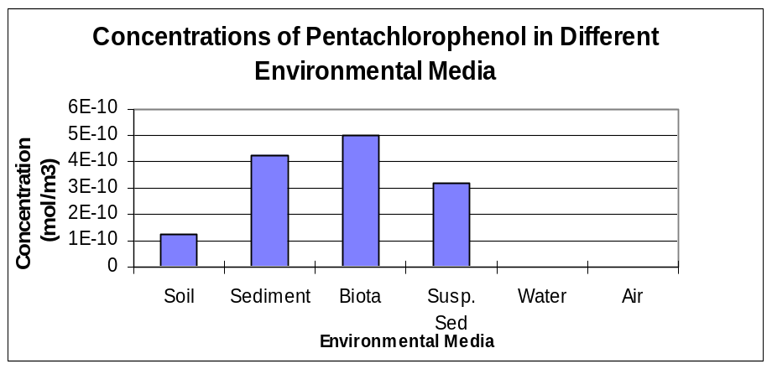

The fugacity level I model also revealed the chemicals that posed the greatest threat to humans via uptake rates. Pentachlorophenol showed the greatest potential, relative to the other chemicals, to be harmful to human health through fish consumption, while 2,6-dinitrotoluene posed the greatest risk to humans through drinking contaminated water. Overall though, hexane was found to have the highest daily uptake by humans via inhalation.
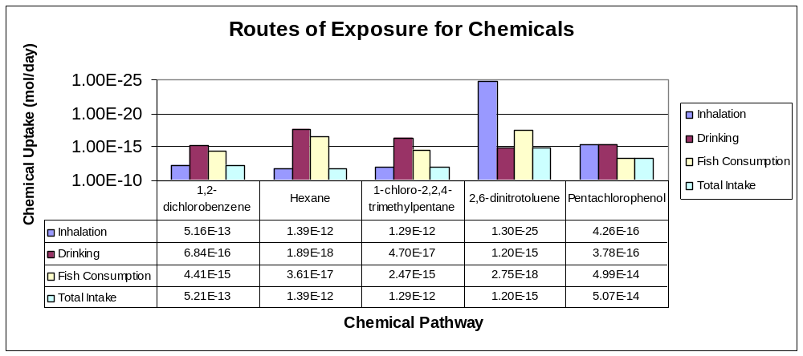
Figure 3.2

Figure 3.2 was generated using an inhalation rate of 20m^3/day, a drinking rate of 2L/day and a fish consumption rate of 0.1 kg/day. The figure confirms that humans should probably be most concerned about hexane and 1-chloro-2,2,4-trimethylpentane which can easily affect locals and factory operators via inhalation.
Effective government regulations and policies can be established to warn human about eating fish. In addition, it may be technically and administratively feasible to prevent neighbouring communities from drinking from a contaminated water reservoir. However, mitigating human exposure to chemicals via inhalation may prove to be a more challenging process. In reference to figures 3.3 and figure 3.4 shown below, the relative distribution of hexane and 1-chloro-2,2,4-trimethylpentane, by mass, leans heavily towards the air phase. Needless to say, handling of hexane and 1-chloro-2,2,4-trimethylpentane should be approached with the utmost precaution. Certainly, both chemicals can easily diffuse into the air phase, which could be most detrimental to human health through daily uptake.

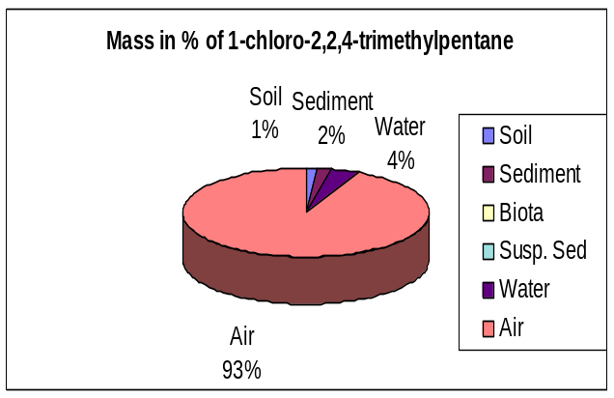
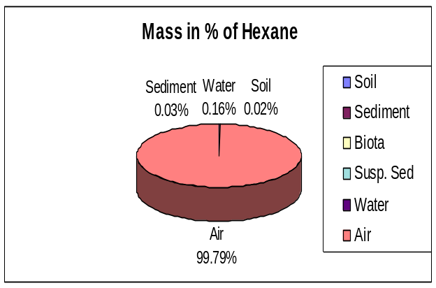
Figure 3.3 Figure 3.4

III. Persistence
The level II fugacity model was valuable in providing insight into the routes of removal and the overall removal time of each chemical substance. The model was also useful by highlighting the environmental mediums in which environmental degradation took place. In reference to figure 4.1, 1,2-dichlorobenzene was shown to have the longest residence time and thus has the highest persistence. Conversely, 2,6-dinitrotoluene had the shortest residence time, followed closely be hexane and 1-chloro-2,2,4-trimethylpentane. A closer look at the reaction rates of each chemical confirmed that environmental remediation through natural processes is more prevalent in water. There is one exeception however--1-chloro-2,2,4-trimethylpentane loss rates mostly took place in the air.

Figure 4.1
Clearly, 1,2-dichlorobenzene has the longest residence time, whereas 2,6-ditintrotoluene has the shortest residence time. Thus, 1,2-dichlorobenzene may have cumulative effects that may beging to surface gradually with time, perhaps more-so than the other chemicals.
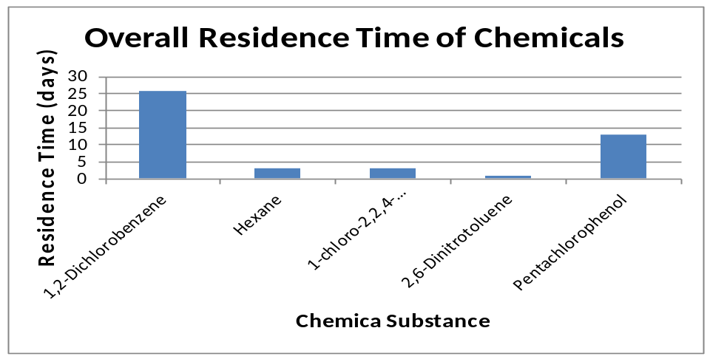

Figure 4.2
This figure shows the reaction rates of each chemical that causes its greatest loss (outflow). The Level II Fugacity Model determined that most of hexane, 1,2-dichlorobenzene,2,6-dinitritoluene, and pentachlorophenol underwent reactions in water, whereas most of 1-chloro-2,2,4-trimethylpentane underwent reactions in air.
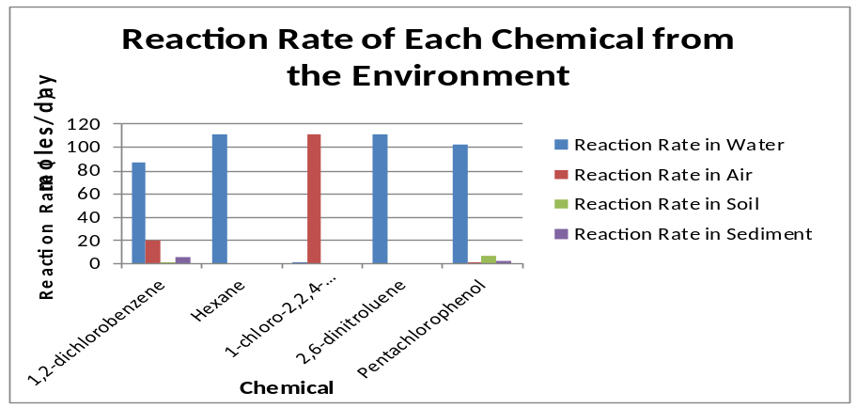

IV. Bioaccumulation Potential
Using the bioaccumulation model created by Gobas (1993), the bioconcentration factors (BCF) in phytoplankton and zooplankton were calculated and analyzed to determine the impending risk of bioaccumulation. Pentachlorophenol and 1,2-chloro-2,2,4-trimethylpentane carried the highest BCF ratios. Thus, the concentrations of these respective chemicals in marine organisms were higher than their concentrations in the surrounding aqueous environment. 2,6-dinitritoluene was shown to have a virtually non-existent risk of bioaccumulation and 1,2-dichlorobenzene presented minimal risk.

Figure 5.1
Pentachlorophenol and 1-chloro-2,2,4-trimethylpentane were shown to have very high BCFs. Also note that both of these aforementioned chemicals had higher Kow’s than the other chemicals, whereas 2,6-dinitritoluene had the lowest Kow of the bunch.
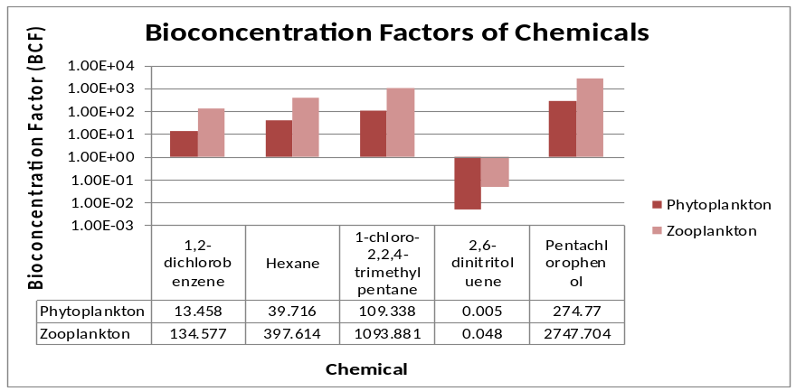

Figure 5.2
This figure shows that pentachlorophenol concentrations increase with higher trophic levels. Also note that Salmonid diet consists mainly of Alewifes and Smelts.
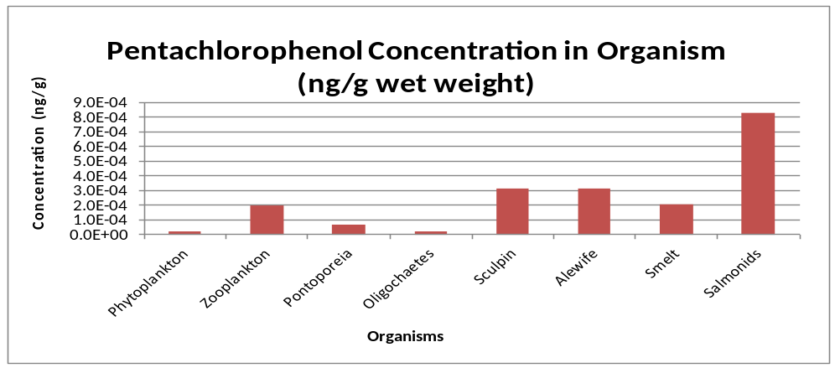

Discussion
Using the environmental impact scoring criteria detailed in the methods section, pentachlorophenol would likely rank first as the chemical with most detrimental effects due its dangerous combination of high toxicity to fish and high persistence in the environment. The low concentration of pentachlorophenol that can cause 50% fish mortality easily negates the fact that pentachlorophenol’s chemical uptake is relatively low in comparison to the other chemical-candidates. Thus, pentachlorophenol’s risk factor is very high to both the community and its constituent locals and indigenous marine species. The chemical that poses the second greatest risk is hexane by virtue of its low LC-50 value and high chemical uptake through inhalation. Though hexane degrades in the environment quite spontaneously, it would still pose considerable risk to permanently employed industry workers and residents who live near the factory and are constantly breathing in the toxic chemical. 1,2-dichlorobenzene would be classified as the third most environmentally-unfriendly chemical due to its high intake rates and very long residence time. While fathead minnows seemed to be somewhat resilient to PCP, it only took a small concentration to trigger rainbow trout mortality, suggesting that 1,2-dichlorobenzene is still somewhat toxic in a marine environment.

Figure 6.1-Categorized Ranking of Chemicals
Chemical | LC-50 | Exposure | Residence time | Bioaccumulation Capacity
1,2-dichlorobenzene | 5 | 3 | 1 | 4
Hexane | 2 | 1 | 4 | 3
1-chloro-2,2,4-trimethylpentane | 4 | 2 | 3 | 2
2,6-dinitritoluene | 3 | 5 | 5 | 5
Pentachlorophenol | 1 | 4 | 2 | 1

1-chloro-2,2,4-trimethylpentane and 2,6-dinitritoluene rank fourth and fifth place, respectively. In the case of 2,6-dinitritoluene, it is moderately toxic but does not seem to pose much of a risk through exposure or bioaccumulation potential. Also, its rate of degradation is incredibly fast, having very short half-lives in the different environmental mediums. 1-chloro-2,2,4-trimethylpentane fits the description of a chemical that could pose a serious threat to humans and the environment through cumulative effects via exposure and residence time, and certainly, it’s large bioconcentration factor could result in irreversible marine ecosystem damage. However, it does not warrant the same immediate precaution associated with the other higher ranked chemicals.

Merits and Limitations
This report presents a very basic assessment of each of the 5 chemicals your company is considering, and as such carries some inconsistencies. Most prominently, all quantitative analyses were conducted under equilibrium and/or steady state conditions. This essentially means that all numerical outputs will carry some semblance of bias or errors. A level III fugacity model would have been the ideal resource in minimizing these errors since it does not assume equilibrium between media nor does it assume each media is of equi-fugacity. While a level II fugacity model is a decent reference point for determining different chemical properties, one of its greatest flaws is that it assumes chemical inflows and outflows are equal, but in a real evaluative environment, this is not so.
As with all deterministic models, conceptually simple methods are used to simulate more complex problems. Incidentally, this report relies on a very simple evaluative environment consisting of only a couple of compartments, but of course, the real world consists of many more compartments. By extension, all chemical fate modeling was conducted using simplified hypothetical scenarios and as such lacks realism. Exposure, uptake, and chemical inflows likely vary with time, but they were only analyzed as constants in this report. It is also possible that environmental stochasticity and other variations could have altered our results. A sensitivity analysis in which parameters were manipulated would have been helpful in detecting these expected changes in output. Furthermore, in the case of any contradictions in literature concerning parameters or inputs in the model, the value that characterized the chemical as “more dangerous” was preferred.
In this report, toxicity (LC-50) was emphasized with greater weight than all other criterion. If a chemical was found to be above a certain toxicity threshold, than it was automatically blacklisted and considered a non-viable alternative to your company’s original chemical cleaning agent. It is arguable that this aforementioned approach could be construed as slightly subjective and biased.

Conclusion
As suggested in the results, this report concludes that 2,6-dinitritoluene would be the most viable choice in replacing your company’s cleaning agent. With a relatively low risk of impact on the local community and the indigenous marine biodiversity, as well as minimal uptake through different routes of human exposure, it is highly recommended that your company consider 2,6-dinitritoluene as a safe product alternative.

References

Chemspider Database (2011, October). Retrieved from http://chemspider.com

Ecotox Database (2011, October). Retrieved from http://cfpub.epa.gov/ecotox/

Environmental and Workplace Health (2007, April 18). Retrieved from http://www.hc-

sc.gc.ca/ewh-semt/pubs/contaminants/psl1-lsp1/1_2_dichlorobenzene/1_2_dichloro

benzene_2-eng.php

Gobas, F.A.P.C. (1993). A model for predicting the bioaccumulation of hydrophobic organic

Chemicals in aquatic food webs: application to Lake Ontario. Ecol. Modeling, 69, 1-17

Goodnight, C. J. (1942). Toxicity of Sodium Pentachlorophenate and Pentachlorophenol To Fish.

Ind. Eng. Chem., 34(7), 868-872. Retrieved from http://pubs.acs.org/doi/abs/10.1021/

ie50391a022

Kullmann, Christian (2011, December). GPS Safety Summary: n-Octyl chloride. Retrieved from

http://corporate.evonik.com/sites/dc/Downloadcenter/Evonik/Corporate/de/Unternehmen/

Verantwortung/gps-summary-n-octyl-chloride.pdf

Liu, J., Ling, H., & Fen, P. (2012). The Effect on n-Hexane on the Gonad Toxicity of Female

Mice. Biomedical and Environmental Sciences, 25(2), 189-196. Retrieved from

http://www.besjournal.com/Articles/Archive/archive/No2/201205/t20120510_60676.htm

Robinson, M., Bercz, J. P., Ringhand H. P., Condie L. W., & Parnell M. J. (1991). Ten- and

Ninety-day toxicity studies of 1,2-dichlorobenzene administered by oral gavage to

Sprague-Dawley rats. Drug Chem Toxicol, 14(1-2), 83-112

Screening Assessment for the Challenge (2009, August). Retrieved from

http://www.ec.gc.ca/ese-ees/default.asp?lang=En&xml=C1B542C5-4A04-DD1F-74D8-

0E7B1459065C

